MS.NET
Mini Project
System and Asset
Management System
(SAMS)

Document Revision History

Date | Revision No. | Author | Summary of Changes
20th Feb. 2014 | 1 | Shashank Saudagar | Initial Draft
11th May 2015 | 1 | Vaishali Kasture | Implementation as per new curriculum
13th July 2016 | 1 | Vijay Vishwakarma | Incorporating changes as per new curriculum

Table of Contents
Introduction 4
Setup Checklist 4
Instructions 4
Problem Statement 5
Objective 5
Abstract of the project 5
Functional components of the project 6
Technology used: 7
Implementation 8
Summary of the functionality to be built: 8
Guidelines on the functionality to be built: 9

Introduction

This document outlines a mini project for the .NET Line of Technology (LOT). The project is to develop ITIM Asset Management System. This document contains the requirements, work flow of the system and gives guidelines on how to build the functionality gradually in each of the course modules of the .NET LOT.

Setup Checklist
Minimum System Requirements
- Intel Pentium 4 and above Windows XP, 2000 and 2003
- Memory 1 GB
- SQL Server 2012 client and access to SQL Server 2012 server
- Visual Studio 2013

Instructions
- The code modules in the mini project should follow all the coding standards.
- Create a directory by your name in drive <drive>. In this directory, create a subdirectory MiniProject. Store your Project here.
- You can refer to your course material.
- You may also look up the help provided in the MSDN
- The total time required to complete this mini project is 43 hrs.
- Since this project work will span over couple of months, you will need to take care of maintaining the code

Problem Statement

Objective

Development of System And Asset Management System
Abstract of the project

System and Asset Management System allows ITIMD department to manage allocation and deallocation of hardware & software assets to different employees. This will also include inventory management of IT infrastructure like computers, monitors, printers and software installations. Along with that user will be able to raise tickets for hardware allocation/transfer and software installations on machines.
This system will have two user types: Employee/User and ITIM Administrator.

Role of ITIM Administrator user
ITIM Administrator is responsible for maintaining the asset inventory and to allocate and deallocate system resources to individual user. Whenever a new employee joins the organization, administrator will enter his/her details into this system and will delete employee details when employee leaves the organization. Following are the responsibilities of an ITIM administrator user.
- Registration of New Employees in the ITIM Asset Management system using Registration Form
- Add / Remove software item from the system repository
- Add / Remove hardware item from the system repository
- Allocation of hardware assets e.g: computer, monitor, laptop, printer etc
- Deallocation of hardware assets
- Software installation/configuration based on tickets
- Approve/Reject software installation ticket based on licensing

Role of Employee user:
Employee user is responsible for raising software ticket by logging on to the system using his/her credentials. Employee can also update their change in location/desk in the system and raise a ticket for asset transfer. Following are the duties of employee user:
- Update Employee location details
- View Asset Details
- Raise Software installation ticket (should mention: software name, durationOfUse, software type :Licensed/Trial/Free & Reason)
- Check ticket status
- Search Software based on licensed, trail or free version

Functional components of the project
Application Architecture:
Distributed web applications traditionally to be designed and built across three logical tiers:
- Database Access Layer (DAL)
- Business Logic Layer (BLL)
- Presentation Layer

The DAL refers to the database itself, the stored procedures, and the component that provides an interface to the database. The BLL refers to the component that encapsulates all the business logic of the application. And, the Presentation layer refers to the web application pages.
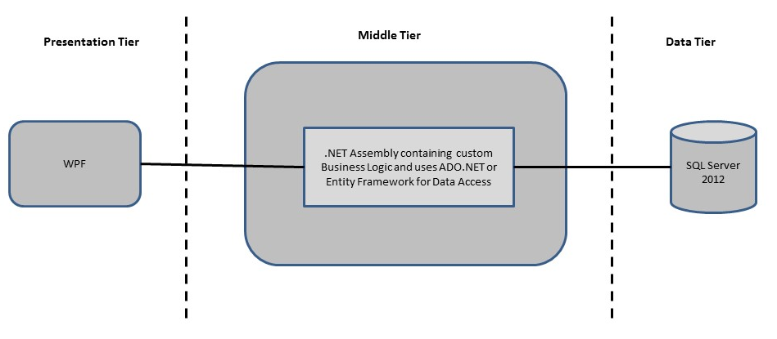
- Design guidelines
- Data access layer of 3-tier useADO.NET data access using SQL stored procedures - All the database interaction would be performed using Data Access Component. Most common methods in Data Access Component would be –
- Create Connection to the Database
- Create Command Object
- Set Command Type to Stored Procedure
- Create and Populate Parameters
- Execute the Command
- Close the Connection

Technology used:
    - Presentation Layer
      - WPF 4.5

    - Business Layer
      - Business Logic Components and Services :-
        - C# 5.0
    - Database Layer
      - Databases:-
        - SQL Server 2012
Sr. No | Course | Duration | Functionality to be built
Sr. No | Course | (in PDs) | Functionality to be built
1 | MS SQL Server 2012 | 4 | Creating relevant database tables and stored procedures
2 | NET Framework 4.5 + C# 5.0 | 7.5 | Developing Business components (C# classes)
3 | ADO.NET 4.5 | 3 | Integrating the DAL ,BLL and PL
4 | LINQ and Entity Framework | 2 | Creating data model and data context and using LINQ to Entities
5 | WPF 4.5 | 2 | Incorporating advanced UI functionality with WPF 4.5
6 | Mini Project Presentation | 1 | The Mini Project Presentation day

Implementation

Summary of the functionality to be built:
The participants need to develop the System and Assest Management System application by building the functionality incrementally in each of the course modules of .NET LOT.

Guidelines on the functionality to be built:

The functionality and components to be built in each of the course modules of .NET LOT is as follows:
- Course: SQL Server 2012
This section describes some of the basic steps involved in designing and creation of the database for the application.

Create Data Model - identify the different tables and fields that we will need, which would later be used for building the rest of the application.

Database Schema - Taking these objects, we can easily identify our main tables in the database.

  - Create the following database tables with following fields:[make your assumptions incase you require few more fields or tables]
      - Hardware_Inventory:HItem_Name,HItem_Id,Location_Id,HItem_Type,Quantity,Reorder_Level
      - Software_Inventory:SItem_Name,SItemId,SItem_Type,IsLicensed,Quantity
      - Employee_Master:Employee_Id,Employee_Name,Location,Joining_Date
      - Allocation_Master: HItem_Id,Employee_Id,Allocation_Date, Serial_No, Location, Alloc_Qty
      - Ticket_Master : Ticket_Id, Created_By, Created_Date, Subject, Description, Expected_Completion_Time, Status,

- Course: WPF 4.5
  - Develop the prototypes for following functionalities:
    - Login / Sign In: Login screen would display asking user to enter ‘User Id’ & ‘Passwd’. If the supplied user credentials are valid the HomePage would be displayed, else appropriate Login error message would be displayed
    - First time users Register: First time new users would use this screen to create their profile (userId and password). On click of ‘Submit’ button new user entry (user id & password) would be saved into database table for further user authentication purpose
    - Home Page: On successful user authentication (validation of userid/password provided by the user in login screen) the homepage would be displayed. The Homepage would contain below sections/contents:

Header section: The header section would be common across all the pages and would mainly have –

Sign In Link – On click it would take to Login page

Main content section: It would display generic Welcome message giving overview of the site.

  - Links For Administrator User :
        - Add New User to the system
        - Add/Modify Software /Hardware Asset
        - Remove Software/Hardware asset
        - Allocate /Deallocate Asset
        - View Ticket details
        - Approve / Reject tickets
  - Links For Employee User :
        - Edit Employee details
        - View Asset details
        - Create Ticket for asset allocation
        - View/Search software asset

  - Any other service provided by ITIM can be included in the project assuming your own table and forms creation.
  - In this course you need to develop the user interface using Winforms and WPF.The screens should include the fields as per the functionality mentioned above. Include Validations where ever required.

- Course: C# 5.0 and ADO.NET 4.5
  - Develop business components (C# classes) for the following functionality:
    - Employee Class: This class will maintain all the Employee information
    - Asset Class : This class will maintain all the asset information
    - Ticket Class: This class will maintain all the ticket details
    - Asset_Allocation: This class will maintain the information about allocation of assets and their allocation details

You need to create Layered Architecture which comprises of PresentationLayer (winforms,WPF),Business Logic Layer (C# Classes) and DAL Layer(Using ADO.Net 4.5 or Linq and Entity Framework)

DAL Layer of ADO.NET 4.5 will include all the required code snippets for CRUD Operations.

All the CRUD operations should use SQL Server Stored Procedures(For Insert,Update,Delete & Search).

The connectionString should be stored in the configuration file only.
OR

- Course: LINQ and EF
  - Using database first approach create a Entity data model based on the database created in the earlier step
    - Hardware_Inventory class :- This class will hold information about the all the hardwares
    - Software_Inventory class:- This class will hold information about all the software
    - Employee_Master class:- This class will hold information of all the employees
    - Allocation_Master class :- This class will hold information of all the hardware allocation
    - Ticket_Master Class :- This class will hold information of the Tickets raised .
  - Using dataContext perform crud operation on the entities and use LINQ to implement the required business logic .

- Course: ADO.NET 4.5 and WPF 4.5
  - Integrate all screens (Winforms,WPF) with business components (C# classes) to complete the entire functionality

Project Evaluation Guidelines
The project it is to be evaluated based on the following five parameters:

- Proper Database Structure and UI designing as per the specifications –(15 Marks)
  - Proper Database Design and Stored Procedure
  - Visual look and feel of the UI
- Project Completion – (20 Marks)
  - Timely Completion of the project
  - Integration of all component of the system
- Defect free execution – (30 Marks)
  - Error free execution of individual modules and the whole system
  - Validation
  - Functionality as per the specified requirements
- Compliance of standard and guidelines – (15 Marks)
  - Appropriate comments entries
  - Adherence to naming conventions for classes, functions, variables and files
  - Simplicity of user interface and screen layouts
  - Maintainability of codes (for example, no one function should be more than 100 lines)
- Group Presentation and Query handling – (20 Marks)
  - Participants (Group of 3 to 4) to present the project with UML Diagrams(use case diagram and one of the sequence or activity diagram) and PPT

